

A Project Report

On

**“PSCS_8 - AI-powered Legal Documentation Assistant”**

Batch Details

|  |  |  |
| --- | --- | --- |
| Sl. No. | Roll Number | Student Name |
| 1 | 20211CSE0846 | VAISHNAVI C |
| 2 | 20211CSE0298 | SHRUTHI V |
| 3 | 20211CSE0308 | RUTHIKA S SHETTY |

**School of Computer Science,**

**Presidency University, Bengaluru.**

Under the guidance of,

**Ms. Sreelatha P.K**

**Associate Professor**

School of Computer Science,

Presidency University, Bengaluru

**CONTENTS**

1. Introduction about Project
2. Literature Review
3. Objectives

## Methodology

1. Timeline for Execution of Project
2. Expected Outcomes
3. Conclusion
4. References

**INTRODUCTION**

Legal documentation is an essential but complex aspect of businesses and personal affairs. Drafting legally sound agreements, contracts, and other documents requires expertise, precision, and adherence to legal terminologies. However, individuals and small businesses often face challenges in understanding and creating legal documents due to a lack of legal knowledge, resources, and access to professional legal assistance.

To address these challenges, this project proposes an AI-powered Legal Documentation Assistant that automates the process of drafting legal documents using Natural Language Processing (NLP) and machine learning techniques. The solution will enable users to generate legally valid documents in plain, understandable language while maintaining accuracy and compliance with legal standards.

This project is implemented entirely in Python, without a front-end or back-end, focusing on backend logic and AI-powered document generation. It utilizes Natural Language Processing (NLP) for understanding and simplifying legal jargon, document processing tools for handling various file formats, and predefined legal templates for structuring the generated content.

**LITERATURE REVIEW**

The study by Rithik Raj Pandey et al uses a Custom Trained GPT model combined with Optical Character Recognition (OCR) technology to process and simplify legal documents. The AI model employs Natural Language Processing (NLP) and pattern recognition techniques to enhance document readability. The platform includes a chatbot for user interaction, allowing users to draft or simplify legal documents, and even consult legal experts through virtual meetings. The solution uses OCR technology to simplify legal jargon and make document creation user-friendly. The system allows users to upload legal documents for processing or interact with a chatbot for guidance. Users can consult with legal experts directly through the platform, adding significant value to the documentation process.

The system integrates legal databases to keep the generated content updated and relevant. The dataset for training the AI model comes from publicly available legal data. **[1]**

The study by Imogen Vimala et al utilizes Natural Language Processing (NLP) and machine learning techniques for contract drafting, document retrieval, and legal text summarization. The system features AI-powered chatbots, semantic analysis, and document automation to enhance efficiency. The tech stack includes HTML, CSS, JavaScript (frontend), PHP (server-side), MySQL (database), and CollectChat (AI chatbot development). The system aims to improve accessibility by providing real-time assistance and customizable legal templates. This initiative not only aims at democratizing legal access but also highlights the importance of technological advancements in legal practices by emphasizing user engagement and customization to meet diverse legal needs.

The dataset for training the AI model is derived from legal document templates, legal research databases, and publicly available legal texts. **[2]**

The study by Awez Shaikh et al employs Large Language Models (LLMs), Natural Language Processing (NLP), and Machine Learning for legal document drafting, summarization, and query handling. The system includes Optical Character Recognition (OCR) for text extraction from PDFs and integrates a secure vector database for document storage. The tech stack comprises a web-based platform with customizable templates, though specific implementation details are not provided. By leveraging advanced technologies such as natural language processing and machine learning, the platform intends to enhance access to legal resources and empower users to navigate legal matters confidently, contributing to a more inclusive legal system.

The dataset for model training is sourced from legal resources, publicly available legal documents, and external legal databases, ensuring accurate and efficient document generation. The system also offers legal chatbot support and expert consultation options. **[3]**

The study by G. Kiran Kumar et al employs Natural Language Processing (NLP) and Optical Character Recognition (OCR) to simplify and generate legal documents. The system features a document drafting engine, a simplification tool, and real-time integration with legal databases. It also prioritizes data privacy and security. The methodology includes iterative AI model refinement, usability testing, and user feedback integration to improve document accuracy and accessibility for small businesses and individuals. The project addresses difficulties faced by non-experts in navigating complex legal documentation in India. Real-time integration with legal databases ensures compliance and accuracy in document generation.

The AI models are trained using publicly available legal datasets, contracts, and case laws, ensuring compliance with the latest legal standards. **[4]**

The study by Lalita Panika et al leverages LangChain, Pinecone, Next.js, Prisma, and MongoDB to build an AI-powered legal documentation platform. The system integrates Natural Language Processing (NLP) for document simplification and generation and uses vector storage (Pinecone) for efficient legal document retrieval. Chatbot functionality powered by OpenAI’s GPT models enables conversational interaction with legal documents. The platform also integrates Swagger UI React for API documentation and Kinde Auth for secure authentication. By minimizing errors and democratizing legal services, SimpliLegal stands as a pivotal innovation enabling broader access to justice and legal information.

The dataset for training the AI models comes from legal databases, case laws, and statutes. **[5]**

The study by Marcos Eduardo Kauffman and Marcelo Negri Soares explores the transformative role of AI in the legal industry. It discusses various AI applications, including document analysis, legal research, and practice automation, which enhance efficiency and reduce costs. However, the study highlights a major challenge in the legal sector: the lack of structured and accessible legal datasets for training AI models. Public legal data, such as judicial decisions, is often scattered across different systems, making it difficult to retrieve and analyze effectively. Additionally, AI systems currently struggle with abstract reasoning and complex legal decision-making, limiting their effectiveness in nuanced cases. While predictive analytics can forecast case outcomes, biases in datasets can result in unfair or unreliable conclusions. Many law firms resist AI adoption due to business models based on billable hours, which do not incentivize automation. Ethical concerns regarding transparency and the fairness of AI decisions further hinder widespread adoption. AI also raises data privacy and cybersecurity risks, especially in handling sensitive legal documents. Despite these challenges, AI continues to revolutionize legal services by automating repetitive tasks and improving access to justice. The paper concludes that interdisciplinary research is needed to address these limitations and ensure AI’s ethical and effective integration into the legal field.

The paper does not specify a particular dataset but mentions that most law firms are "document-rich but data-poor," with legal data being either unavailable or inconsistent in format. **[6]**

The study by Sayash Kapoor et al examines AI’s role in legal tasks, focusing on three key areas: information processing, tasks requiring creativity or judgment, and predictive analytics. However, the paper points out significant issues with these datasets, such as biases, inaccuracies, and data contamination, where training data overlaps with test data, leading to inflated performance estimates. AI models are trained on these datasets to perform tasks like legal information retrieval, case prediction, and document summarization. While generative AI systems like GPT-4 and predictive models such as COMPAS have been applied to legal tasks, the quality of the datasets used remains a critical concern. The paper emphasizes that the lack of clean, unbiased, and comprehensive datasets is a major challenge in effectively evaluating AI in legal settings. Despite these issues, the study suggests that AI could be useful for automating routine legal tasks but is far from replacing human judgment in more complex legal matters.

The paper discusses datasets commonly used in legal AI applications, which typically include judicial decisions, case law, public legal documents, and legal filings. These datasets are often retrieved from open-access legal databases, court records, and law-specific archives. **[7]**

The study by Dr. Lance B. Eliot explores the integration of Artificial Intelligence (AI) in legal argumentation. It introduces the Levels of Autonomy (LoA) of AI Legal Reasoning (AILR), a framework that categorizes AI’s role in legal decision-making from basic assistance to full autonomy. AI techniques such as Natural Language Processing (NLP), Machine Learning (ML), Deep Learning (DL), and Knowledge-Based Systems (KBS) are discussed as potential tools for legal reasoning. The paper proposes the CARE Model (Crafting, Assessing, Refining, and Engaging) to describe AI’s involvement in legal argumentation. The study highlights a gap in real-world AI applications for legal reasoning, as current systems remain largely theoretical or at prototype stages. Key disadvantages include lack of structured datasets, interpretability issues, and ethical concerns surrounding AI’s role in law. The research emphasizes that AI legal reasoning must be explainable and justifiable to gain acceptance in professional practice. While AI holds promise for enhancing legal analysis, full automation remains a distant goal due to legal complexities and contextual nuances. The paper calls for further research into ethical, regulatory, and societal implications before AI can be widely adopted in legal decision-making.

The study does not use a specific structured dataset but relies on theoretical models, prior legal research, and various academic references as its foundation. Instead of retrieving data from a centralized source, the paper draws from existing legal texts, AI research papers, and conceptual frameworks. **[8]**

The study by Jiaxi Cui et al. introduces an AI-based legal assistant designed to improve the accuracy and reliability of legal consultations. The model employs a Mixture-of-Experts (MoE) framework, integrating knowledge graphs, retrieval-augmented generation (RAG), and multi-agent collaboration to ensure accurate legal reasoning. The system features four specialized agents—Legal Assistant, Legal Researcher, Lawyer, and Legal Editor—which simulate real law firm workflows to provide structured legal services. The study demonstrates that Chatlaw outperforms GPT-4 by 7.73% in accuracy on Lawbench and by 11 points in the Unified Qualification Exam for Legal Professionals, highlighting its superior legal text understanding and reasoning capabilities. Despite its advantages, the paper identifies key research gaps, such as hallucination issues, dataset limitations, and the need for better AI explainability. Major disadvantages include high computational costs, privacy concerns, and limited generalization to legal systems outside China. Additionally, AI bias and interpretability challenges necessitate human verification in legal decision-making. The paper emphasizes that while AI can significantly enhance legal services, full automation remains challenging due to contextual complexities and ethical considerations. Future research should focus on improving dataset diversity, enhancing security, and reducing computational resource demands for practical implementation.

It utilizes a high-quality legal dataset sourced from multiple legal documents, case laws, and legal repositories, enhanced with knowledge graphs and manual refinement by legal experts. **[9]**

The study by Quinten Steenhuis et al explores the use of generative AI for automating the drafting of interactive legal applications. The study employs GPT-3 and GPT-4-turbo to generate legal interview questions and assist in form automation. Three approaches are tested: a fully AI-driven method, a constrained template-based approach, and a hybrid model combining AI with human review. The findings suggest that the hybrid model is the most effective, reducing human effort while maintaining accuracy. The paper highlights a research gap in fully automated legal form generation, as AI struggles with complex conditional logic and contextual legal understanding. Key disadvantages include hallucination risks, difficulties in handling diverse legal documents, and limitations in checkbox recognition within PDFs. Additionally, AI-generated forms require significant human review to ensure compliance and usability. The study suggests further improvements in AI-assisted legal automation, particularly in refining question logic and improving PDF field recognition. Overall, the research demonstrates that AI can accelerate legal form automation but cannot replace human oversight in complex legal workflows.

It utilizes legal forms and templates from various court systems and organizations, processed through the Assembly Line Weaver tool. **[10]**

The study by Drashti Shah, Jai Vasi, Tanik Gandhi, and Prof. Kanchan Dabre explores the use of Artificial Intelligence (AI) and Machine Learning (ML) in legal assistance, specifically for analyzing employment and loan contracts. It employs Retrieval-Augmented Generation (RAG) models, Optical Character Recognition (OCR), and Natural Language Processing (NLP) techniques such as BERT and GPT to extract and interpret legal information. The proposed system allows users to upload legal documents and interact with an AI-powered chatbot for legal guidance, making legal assistance more accessible. However, the research identifies key gaps, including lack of contextual understanding, difficulty in handling diverse document formats, and challenges in semantic inference. The main outcome is a community-based legal advice platform that connects users with legal professionals and provides AI-generated legal insights. Despite its advancements, the system has limitations, such as dependence on OCR accuracy, misinterpretation of legal language, and privacy concerns. It also struggles with adaptability to different legal systems, limiting its global applicability. The research emphasizes the need for better document handling techniques and improved semantic interpretation for more accurate legal AI systems. Overall, the paper contributes to the automation of legal processes but requires further refinement to overcome its challenges.

The dataset used consists of legal documents, including employment contracts, loan agreements, and judicial case records, but the specific retrieval source is not mentioned. These documents are semi-structured and unstructured, requiring text extraction and processing techniques to handle different formats like PDFs, scanned images, and Word files. **[11]**

The study by Jhanvi Aroraa et al explores AI-driven legal research using Natural Language Processing (NLP) and Information Retrieval techniques. It utilizes BM25, Topic Embeddings (Top2Vec), Law2Vec embeddings, and BERT-based classification to retrieve relevant legal precedents and statutes. The system effectively automates legal precedent retrieval and classifies legal text into rhetorical roles. However, the research identifies key gaps, such as limited context awareness, challenges in processing lengthy documents, and data imbalance in classification tasks. The main outcome of the paper is an AI-based legal research assistant that improves the efficiency of legal document retrieval and ranks among the top 10 submissions at FIRE 2020. Despite its advancements, the system has disadvantages, including BM25’s lack of deep contextual understanding, high computational costs of BERT, and inefficiencies in soft cosine similarity calculations. Additionally, topic modeling methods may lose case-specific details, affecting retrieval accuracy. The paper highlights the need for better abstraction techniques and hyperparameter tuning to enhance precision. Overall, the research contributes to automating legal research, but further improvements are required for greater accuracy and efficiency.

The dataset includes 3,260 case documents and 197 statutes, retrieved from the Forum for Information Retrieval Evaluation (FIRE) 2020. **[12]**

The study by Pranav Nataraj Devaraj et al presents a chatbot designed to assist with legal document queries. It utilizes Langchain, an NLP framework, along with GPT-based Large Language Models (LLMs) to process and retrieve information from uploaded legal documents and the Indian Constitution. The chatbot uses Cosine Similarity to compare user queries with stored text chunks, while a Flask-based backend provides a REST API for query processing. The outcome of the research is a functional Android-based chatbot capable of answering legal queries using context-aware retrieval techniques. However, the study identifies gaps, including limited AI training capabilities, restricted query token limits, and scalability challenges. Additionally, the chatbot depends on pre-uploaded documents, lacks a real-time legal database, and struggles with complex legal reasoning beyond keyword matching. The system also faces computational inefficiencies when processing large documents and potential security risks due to storing sensitive legal texts on a server. Despite these limitations, the research provides a solid foundation for AI-driven legal assistance, with future improvements needed in adaptive learning, document sourcing, and enhanced user experience.

The dataset consists of pre-uploaded legal texts, stored in a backend server, which are broken into vector embeddings for efficient search and retrieval. **[13]**

The study by Jinqi Lai et al explores the applications of large language models (LLMs) in the legal field. It discusses how AI can assist judges, automate legal document generation, and improve efficiency in legal research. The study highlights that legal LLMs are trained on judicial case records, legal statutes, and court decisions, but data accessibility remains a challenge due to privacy concerns. Algorithms such as BERT, GPT, and specialized legal models like ChatLaw and LawGPT are used for text processing and decision-making. However, the paper identifies research gaps, including biased AI outputs, lack of dataset standardization, and limited interpretability of legal decisions. Ethical concerns such as predictive policing and AI-driven judicial decisions potentially undermining human rights are also raised. One major disadvantage of legal LLMs is their tendency to reinforce biases from historical legal data, leading to unfair verdicts. The study also warns that over-reliance on AI could weaken judicial independence, limiting a judge’s discretionary power. Additionally, the lack of benchmarking and real-world testing makes it difficult to assess the true effectiveness of these models. While the paper provides recommendations for improving legal AI, it emphasizes the need for transparency, fairness, and better dataset governance to ensure responsible adoption. **[14]**

The study by Nguyen Ha Thanh introduces LawGPT 1.0, an AI-powered legal assistant fine-tuned on GPT-3 for the legal domain. LawGPT 1.0 uses the transformer architecture with attention mechanisms and fine-tuning techniques to generate legal documents, answer legal queries, and provide legal advice. Despite its capabilities, the study highlights several limitations, such as the lack of explainability, which raises concerns about trust and accountability in AI-generated legal decisions. Additionally, the model does not support Reinforcement Learning from Human Feedback (RLHF), reducing its ability to refine responses based on user interactions. Ethical and legal concerns regarding privacy, responsibility, and potential bias in AI-generated legal recommendations remain unaddressed. Another major drawback is that LawGPT 1.0 currently supports only English, limiting its applicability in multilingual legal systems. The study suggests future improvements, including expanding language support and integrating better explainability features, but these enhancements have yet to be implemented. The lack of transparency regarding dataset sources and the absence of real-world deployment discussions further weaken its practical reliability. Despite these limitations, LawGPT 1.0 shows potential for improving legal service accessibility, making AI-driven legal assistance available 24/7.

The model is trained on a large corpus of legal text, though the exact dataset source is undisclosed due to a Non-Disclosure Agreement (NDA). **[15]**

**ADVANTAGES AND DISADVANTAGES**

1. **LegalSeva: An AI - Powered Legal Document Assistant**

**Advantages:**

* Converts complex legal jargon into easy-to-understand language.
* Helps individuals and small businesses who lack legal expertise, improving access to justice.
* Automates document drafting, reducing the time required for legal paperwork.

**Disadvantages:**

* Custom-trained GPT may require continuous updates to maintain accuracy.
* Training data limitations could introduce biases, affecting fairness in legal document generation.
* Handling sensitive legal data requires strong security measures to prevent breaches.

1. **AI - Powered Legal Documentation Assistant**

**Advantages:**

* Focuses on copyright, trademark, and banking law, making it more domain-specific.
* Provides personalized legal assistance and explanations through an AI chatbot.

**Disadvantages:**

* Primarily uses CollectChat, which may not be as powerful as GPT-based AI solutions.
* Storing sensitive legal documents online poses security and privacy risks.

1. **AI - Powered Legal Documentation Assistant**

**Advantages:**

* Allows users to search and extract specific legal information from PDFs efficiently.
* Users can modify documents based on specific needs.

**Disadvantages:**

* AI primarily focuses on summarization and document management rather than deep legal analysis.
* AI may not fully grasp legal nuances, requiring human review for important documents.

1. **AI - Powered Legal Documentation Assistant**

**Advantages:**

* Designed to be accessible to non-lawyers with minimal legal knowledge.
* Uses NLP and AI models to automatically generate legal documents.

**Disadvantages:**

* Some legal terms and scenarios may be misinterpreted, requiring manual adjustments.
* Vague or incomplete inputs may lead to suboptimal document generation.

1. **SimpliLegal: An AI - Powered Legal Document Assistant**

**Advantages:**

* Allows users to engage in chats with their documents for better understanding.
* Users can consult legal professionals for complex legal matters.

**Disadvantages:**

* AI-generated documents might contain inaccuracies due to limitations in training data.
* Uses multiple modern technologies, requiring high maintenance and updates.

1. **AI in legal services: new trends in AI-enabled legal services**

**Advantages:**

* AI assists in document drafting, legal research, and e-discovery, freeing up time for lawyers to focus on complex cases.
* AI can analyze past court rulings to help predict legal outcomes, aiding lawyers in case strategy.
* AI allows law firms to handle a larger volume of cases and clients without increasing operational costs significantly**.**

**Disadvantages:**

* AI systems trained on biased legal datasets may reinforce existing legal prejudices.
* AI struggles with abstract reasoning and cannot fully grasp the complexities of legal arguments.
* Handling confidential legal information with AI increases the risk of data breaches**.**

1. **Promises and pitfalls of artificial intelligence for legal applications**

**Advantages:**

* AI-powered tools can help individuals understand legal information without requiring expensive legal consultations.
* AI-driven automation can lower costs by reducing reliance on human labor for repetitive legal tasks.
* AI systems can handle large volumes of legal data and cases, allowing for broader application across multiple legal domains.

**Disadvantages:**

* AI models often rely on biased or flawed datasets, leading to inaccurate or unfair predictions.
* AI-generated legal documents and case predictions can contain false or misleading information, making them unreliable.
* Many AI legal models function as "black boxes," making it difficult to understand how they arrive at specific conclusions.

1. **AI and Legal Argumentation: Aligning the Autonomous Levels of AI Legal Reasoning**

**Advantages:**

* AI can assist in crafting, assessing, refining, and engaging in legal argumentation, improving efficiency in legal processes.
* The paper introduces the Levels of Autonomy (LoA) for AI Legal Reasoning (AILR), which provides a structured way to measure AI progress in legal reasoning.
* AI can aid in document analysis, case predictions, and argument evaluation, reducing manual effort for legal professionals.

**Disadvantages:**

* AI-driven legal reasoning often functions as a "black box," making it difficult to understand or justify its decisions.
* The adoption of AI in legal reasoning raises concerns about fairness, accountability, and bias in automated legal decision-making.
* AI systems require large, high-quality legal datasets, which may not always be available or may contain biases.

1. **Chatlaw: A Multi-Agent Collaborative Legal Assistant with Knowledge Graph Enhanced Mixture-of-Experts Large Language Model**

**Advantages:**

* Enhances response reliability by structuring legal knowledge and ensuring AI recommendations are fact-based.
* Uses specialized AI agents (Legal Assistant, Researcher, Lawyer, and Editor) to replicate real-world legal workflows.
* The model processes vast amounts of legal data, allowing faster and more precise legal consultations.

**Disadvantages:**

* Running a Mixture-of-Experts model requires high computational resources, making real-time processing expensive.
* Handling sensitive legal data raises issues regarding confidentiality and user trust.
* AI models trained on biased legal data could reinforce unfair legal precedents.

1. **Weaving Pathways for Justice with GPT**

**Advantages:**

* Automating legal forms helps individuals who lack legal expertise, improving access to justice.
* The system can process and automate a large number of legal forms, making it easier to implement legal automation on a wider scale.
* The use of the open-source Docassemble platform allows compatibility with existing legal document automation tools.

**Disadvantages:**

* The system struggles with forms requiring conditional logic or deep legal reasoning, necessitating manual refinement.
* The model had difficulty recognizing checkboxes and specific fields in PDF-based legal forms.
* Running GPT-based automation at scale requires significant computational power.

1. **AI & ML Based Legal Assistant**

**Advantages:**

* Uses Retrieval-Augmented Generation (RAG), OCR, and NLP (BERT, GPT) for effective legal document analysis.
* Provides an AI-powered chatbot for legal guidance, improving accessibility.

**Disadvantages:**

* Dependence on OCR accuracy can lead to misinterpretation of legal language.
* Struggles with adapting to different legal systems, limiting global usability.

1. **Artificial Intelligence as Legal Research Assistant  
   Advantages:**

* Automates legal precedent retrieval with BM25, Top2Vec, and Law2Vec, improving efficiency.
* Ranked among the top 10 submissions at FIRE 2020, showcasing strong performance.

**Disadvantages:**

* BM25 lacks deep contextual understanding, limiting retrieval accuracy.
* High computational costs of BERT-based models make real-time processing challenging.

1. **Development of a Legal Document AI-Chatbot**

**Advantages:**

* Uses Langchain and GPT-based LLMs for efficient legal document retrieval.
* Android-based chatbot provides user-friendly access to legal information.

**Disadvantages:**

* Limited by pre-uploaded documents, lacking real-time legal database access.
* Computational inefficiencies in processing large legal texts.

1. **Large Language Models in Law: A Survey**

**Advantages:**

* Explores LLM applications in law, covering AI-assisted judicial decisions and document automation.
* Highlights key models like BERT, GPT, ChatLaw, and LaWGPT, offering a broad perspective.

**Disadvantages:**

* AI-driven decisions risk reinforcing biases from historical legal data.
* Over-reliance on AI could undermine judicial independence and discretionary power.

1. **LawGPT 1.0 - A Virtual Legal Assistant Based on GPT-3**

**Advantages:**

* Fine-tuned on legal text, making it well-suited for legal queries and document generation.
* Provides 24/7 AI-driven legal assistance, enhancing accessibility.

**Disadvantages:**

* Lacks explainability, reducing trust and accountability in AI-generated legal decisions.
* Supports only English, limiting its usability in multilingual legal systems.

**OBJECTIVES**

1. **Automate Legal Document Drafting Using AI**

* Develop an AI-based system to generate legal documents with minimal human effort.
* Use Natural Language Processing (NLP) for structuring, formatting, and populating documents.
* Implement predefined templates for different legal document types (contracts, NDAs, agreements).

1. **Simplify Legal Language for Better Accessibility**

* Convert complex legal jargon into plain, understandable language while preserving legal intent.
* Utilize NLP techniques such as text summarization and language simplification.
* Provide explanations for key legal terms to enhance user comprehension.

1. **Ensure Accuracy and Compliance with Indian Legal Frameworks**

* Integrate legal databases and regulatory resources to ensure compliance with Indian laws.
* Validate generated documents using pre-trained legal language models to detect inconsistencies.
* Implement clause verification to ensure inclusion of important legal provisions.

1. **Provide Customization Options Based on User Needs**

* Allow users to input specific details (e.g., parties, terms, contract duration) for personalized documents.
* Implement a modular document generation system with selectable clauses and conditions.
* Support multiple legal document types such as business contracts and employment agreements.

1. **Improve Accessibility to Legal Documentation for Small Businesses & Individuals**

* Offer a cost-effective alternative to legal professionals for drafting basic documents.
* Reduce time and effort required for manual legal paperwork.
* Enable users with no legal background to generate legally sound documents efficiently.

**EXPERIMENTAL DETAILS/METHDOLOGY**

Software used:

* Python 3.x
* Jupyter Notebook / Google Colab
* spaCy (for text processing and legal terminology simplification)
* NLTK (for additional text processing if needed)
* OpenAI GPT or Llama (for AI-powered document generation)
* pdfminer or PyMuPDF (for reading legal PDFs)
* docx (for working with Word documents)
* pandas (for structuring legal datasets)

**METHODOLOGY**

**I. Overview**

The development of the AI-powered Legal Documentation Assistant follows a structured methodology to ensure the accuracy, reliability, and efficiency of the system. The project is implemented using Python-based AI models, specifically focusing on legal document retrieval and analysis. The methodology consists of five key phases: Data Collection, Preprocessing, Model Development, Document Retrieval, and Validation. Each phase plays a crucial role in refining the AI system for handling complex legal texts, extracting key legal terms, and retrieving relevant legal documents based on user queries.

**II. Data Collection and Preprocessing**

**a. Legal Dataset Acquisition**

A comprehensive dataset is essential for training and fine-tuning the AI model. The data is gathered from multiple publicly available sources, including government legal repositories, open-source legal documents, law firm databases, and case law collections. The dataset includes different types of legal documents such as contracts, agreements, policies, and legal notices. To ensure data quality and relevance, legal experts review the collected materials, eliminating outdated or jurisdiction-specific content that may reduce the model’s generalization capability.

**b. Text Cleaning and Formatting**

Once collected, the raw legal data undergoes rigorous preprocessing to enhance its quality and usability for AI training. This includes:

* Removing Special Characters and Formatting Artifacts – Unnecessary symbols, extra spaces, and formatting errors (e.g., page numbers, footnotes, and metadata) are removed to maintain textual clarity.
* Tokenization – The text is split into sentences and words for structured analysis.
* Stopword Removal – Common but non-informative words (e.g., “the,” “is,” “an”) are filtered out to focus on meaningful legal content.
* Lemmatization – Words are reduced to their root forms to improve consistency across different word variations (e.g., “running” → “run”).

**III. AI Model Development**

1. **Legal Document Embeddings and Vector Search**

The system utilizes text embeddings for efficient document retrieval. The methodology includes:

* Embedding Generation – Legal texts are converted into numerical vector representations using Hugging Face transformer models.
* Dimensionality Reduction with PCA – Principal Component Analysis (PCA) is applied to reduce the vector size while preserving essential semantic information.
* Efficient Similarity Search with FAISS & HNSW – The system leverages Hierarchical Navigable Small World (HNSW) graphs and FAISS (Facebook AI Similarity Search) to enable fast and scalable retrieval of similar legal texts.

1. **Conversational Retrieval-Based Model**

To improve legal information retrieval, the system incorporates:

* Conversational Retrieval Chains – The system refines queries iteratively to provide the most relevant legal documents.
* Legal Context Awareness – The model understands user queries in context, retrieving relevant legal information effectively.
* Query Expansion & Re-ranking – Queries are expanded using related legal terms, and retrieved documents are ranked based on semantic relevance.

**IV. Legal Document Retrieval**

1. **User Query Processing**

The system processes user queries to retrieve the most relevant legal documents. Key steps include:

* Semantic Query Embedding – Converting user input into an embedding vector to match with stored legal document embeddings.
* Similarity Matching – Using FAISS and HNSW for efficient document similarity search.
* Ranking & Filtering – Prioritizing the most relevant legal documents and removing irrelevant results.

1. **Dynamic Legal Text Retrieval**

The retrieved legal texts are:

* Structured Based on Context – Ensuring that documents align with user intent.
* Ranked by Relevance – Higher-ranked documents contain more pertinent legal information.
* Adaptive to User Queries – The system refines search results based on user feedback.

**V. Validation and Testing**

**a. Comparison with Existing Legal Documents**

The retrieved outputs are benchmarked against established legal document templates to ensure:

* Structural Consistency – Matching real-world legal document frameworks.
* Completeness – Ensuring all necessary clauses are present and properly formatted.

**b. Performance Metrics**

Since the system focuses on retrieval rather than text generation, evaluation is performed using:

* Recall and Precision – Measuring how accurately the system retrieves relevant legal documents.
* MRR (Mean Reciprocal Rank) – Evaluating how high the relevant document appears in ranked results.
* Embedding Similarity Scores – Assessing how close the retrieved legal documents are to the query input.

**VI. Ethical Considerations and Future Enhancements**

1. **Data Privacy and Security**

Given the sensitivity of legal information, security measures include:

* Anonymization of Sensitive Data – Redacting personal details to protect user privacy.
* Encryption Mechanisms – Securing stored and transmitted legal data.
* Compliance with Privacy Regulations – Adhering to GDPR (General Data Protection Regulation) and other data protection laws.

1. **Future Enhancements**

To expand functionality, the system aims to:

* Support Multiple Languages – Enhancing accessibility for non-English legal documents.
* Integrate Real-Time Legal Consultation – Providing AI-powered assistance for legal queries.
* Extend Document Types – Supporting wills, power-of-attorney documents, and regulatory compliance reports.

This structured methodology ensures that the AI-powered Legal Documentation Assistant efficiently retrieves and analyzes legal texts with high accuracy. By integrating text embeddings, semantic search, and conversational retrieval chains, the system enhances legal documentation processes, benefiting legal professionals and organizations.

**OUTCOMES**

1. **Automated Legal Document Generation –** The system will generate legal documents in plain language based on user inputs, reducing the need for manual drafting.
2. **Improved Accessibility to Legal Resources –** Individuals and small businesses will be able to create legally sound documents without requiring extensive legal knowledge or professional assistance.
3. **Reduction in Errors and Ambiguities –** By utilizing AI and NLP techniques, the system will minimize common mistakes and misunderstandings in legal documents, ensuring clarity and accuracy.
4. **Time and Cost Savings –** Users will save significant time and legal expenses by automating the document drafting process rather than hiring a lawyer for basic legal paperwork.
5. **Integration with Legal Databases –** The AI model is expected to use publicly available legal resources to ensure that documents align with current legal standards and regulations.

**TIMELINE OF THE PROJECT/ PROJECT EXECUTION PLAN**

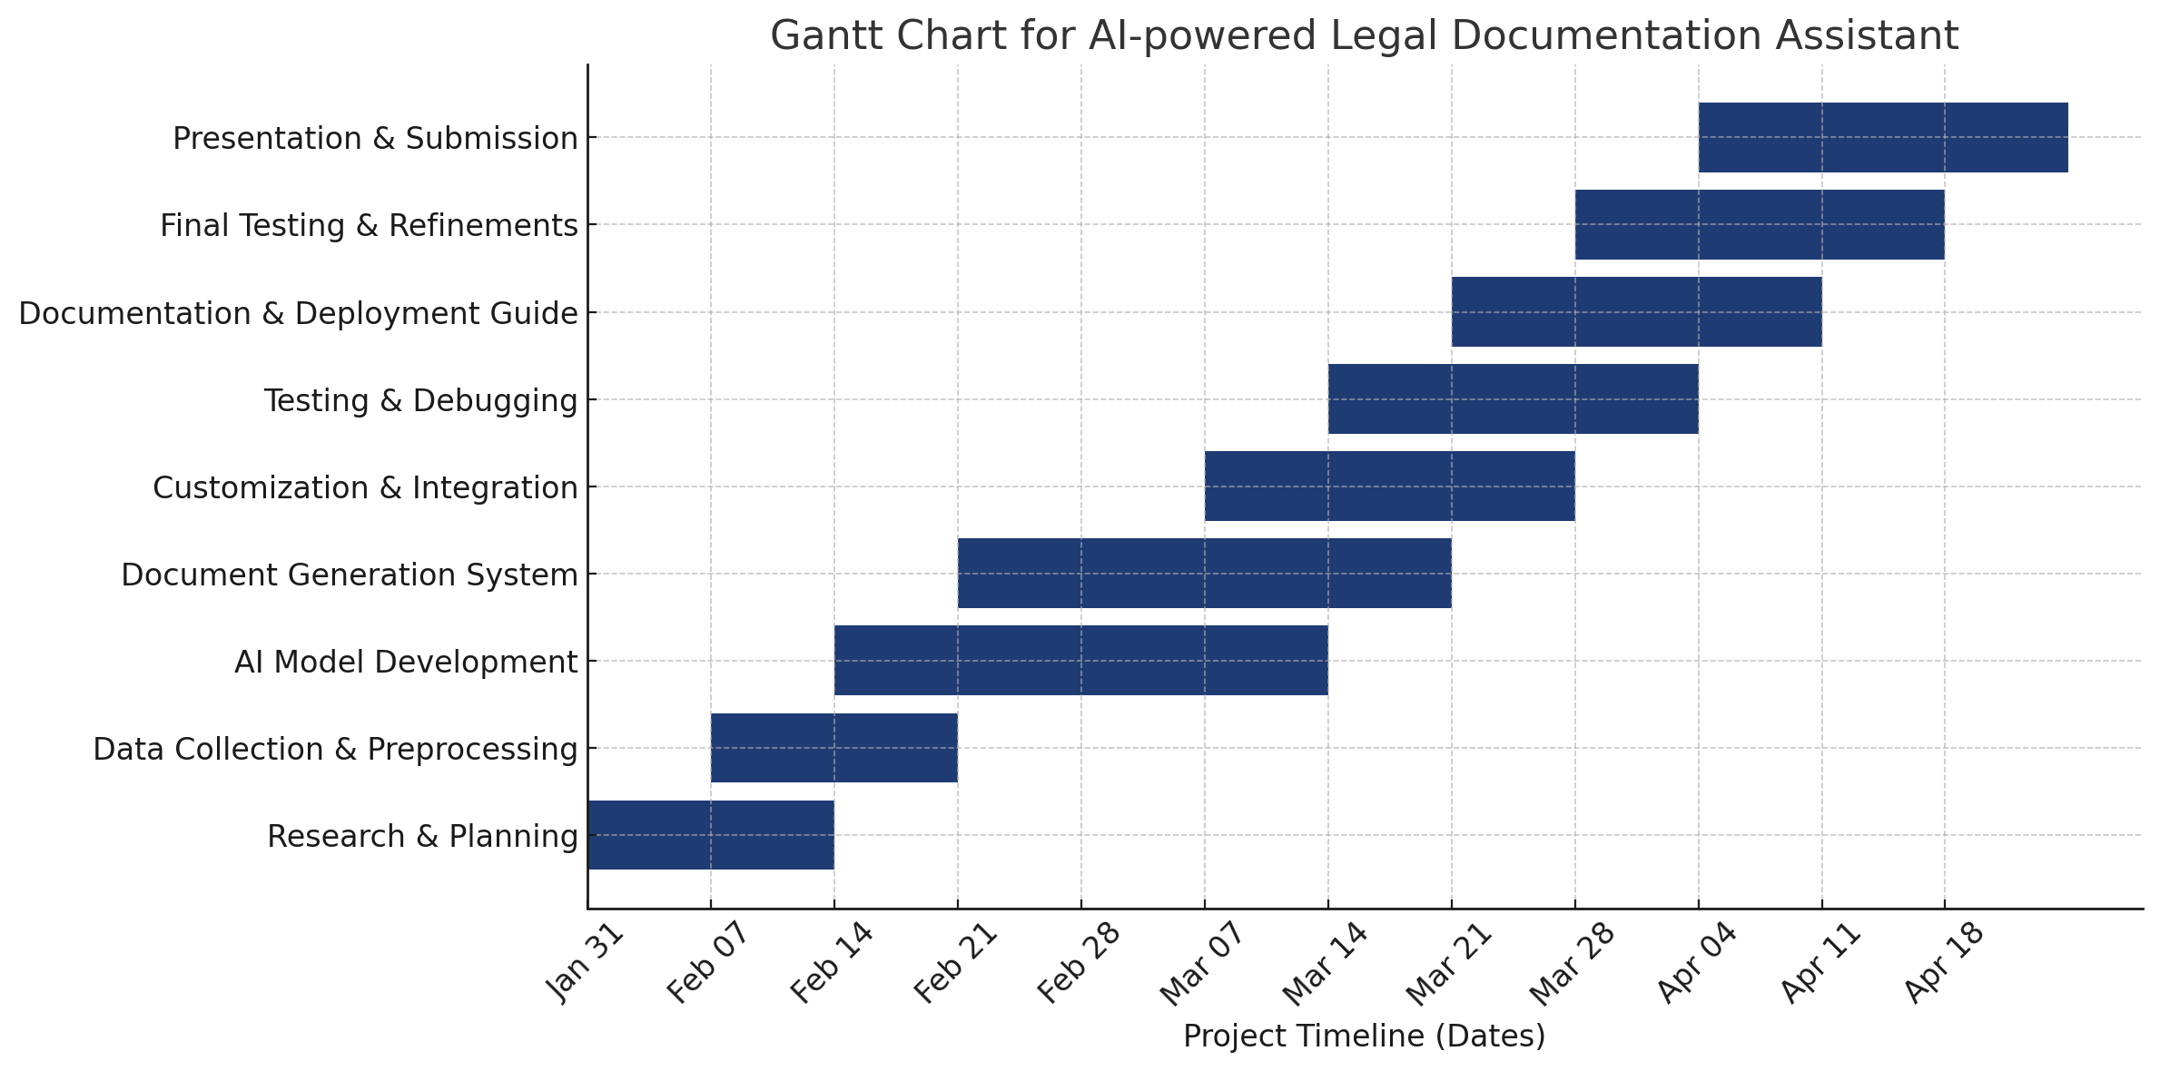

**RESULTS AND DISCUSSIONS**

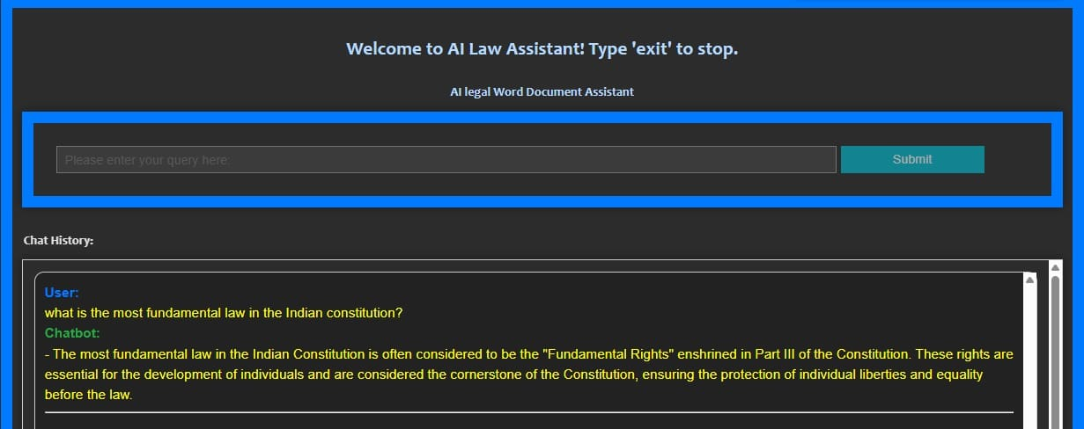

**Fig. 1**

Fig. 1 displays the output interface of the AI Legal Word Document Assistant, an AI-powered chatbot designed to assist users with legal queries. At the top, the interface welcomes users with a message and provides an instruction to type 'exit' to stop the interaction. The main section includes a query input field (highlighted in blue), where users can enter their legal questions, along with a submit button that processes the input. Below this, the chat history section displays the conversation between the user and the chatbot. In the image shown, the user asked about the most fundamental law in the Indian Constitution, and the chatbot responded by explaining that Fundamental Rights, enshrined in Part III of the Constitution, form its cornerstone.

The response is generated through a document-based retrieval system. When a user enters a query, the system first extracts and preprocesses legal text from PDF files using PyMuPDF (fitz). The text is structured into headings and corresponding content, allowing the system to efficiently search for relevant information. When a query is received, it is processed to identify key terms and matched against the extracted legal text. The system primarily relies on keyword-based search and text-matching techniques to locate relevant sections. The retrieved information is then formatted into a structured response and displayed in the chat history.

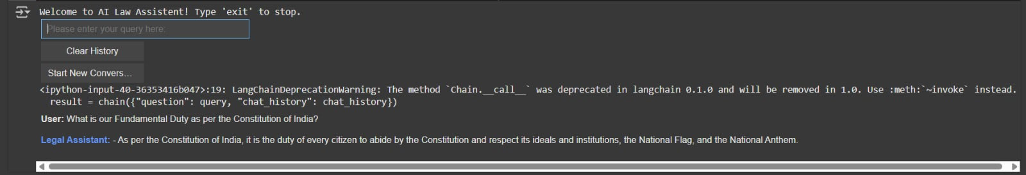**Fig. 2**

In Fig. 2, the user asked about the Fundamental Duty as per the Constitution of India, and the chatbot responded with an explanation based on constitutional provisions.

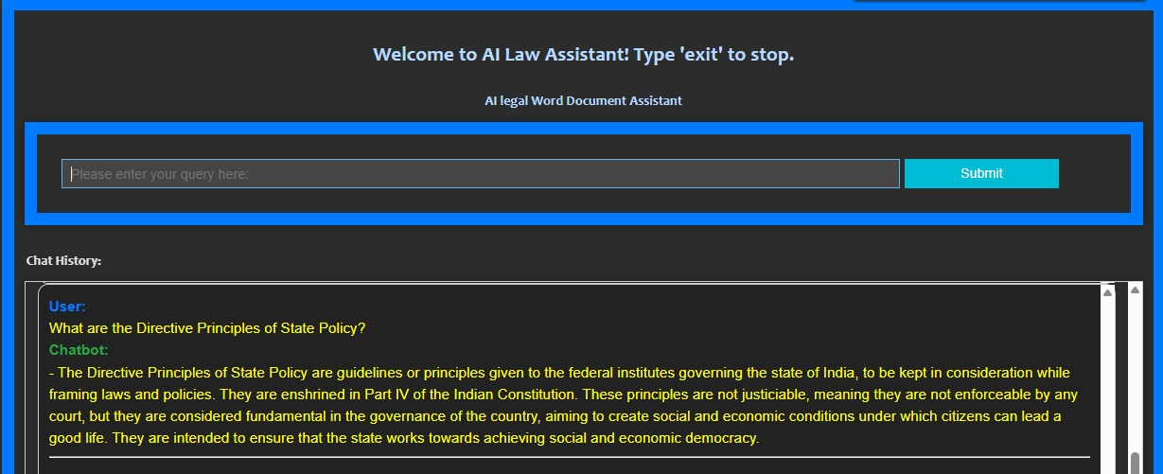

**Fig. 3**

In the above image, the user asked: "What are the Directive Principles of State Policy?" The chatbot responded with a detailed explanation, stating that the Directive Principles of State Policy (DPSP) are guidelines for governance in India, enshrined in Part IV of the Indian Constitution. It highlights that while these principles are not justiciable (i.e., not enforceable by courts), they serve as fundamental guidelines to ensure social and economic democracy.

**CONCLUSION**

The AI-powered Legal Documentation Assistant simplifies the legal drafting process for individuals and small businesses by generating accurate and easy-to-understand legal documents. By leveraging natural language processing (NLP) and machine learning techniques, our solution ensures that users can create legally sound documents without requiring extensive legal expertise.

Throughout the project, we developed a robust AI model capable of document generation, customization, and integration with legal resources. The system was designed with a focus on accuracy, efficiency, and usability, ensuring that users can generate documents with minimal errors while maintaining compliance with legal standards.

This project has the potential to significantly impact legal accessibility in India, where many individuals and small businesses struggle with complex legal paperwork due to a lack of resources. By reducing the time, effort, and costs associated with legal documentation, our solution promotes greater legal awareness and accessibility.

**REFERENCES**

[1]. Rithik Raj Pandey, Sarthak Khandelwal, Satyam Srivastava, Yash Triyar and Mrs. Muquitha Almas, “LegalSeva: AI - Powered Legal Documentation Assistant”, International Research Journal of Modernization in Engineering Technology and Science, vol. 06/Issue:03, March 2024.

[2]. Imogen Vimala, Sreenidhi J. and Nivedha V, “AI - Powered Legal Documentation Assistant”, Journal of Artificial Intelligence and Capsule Networks. 6. 210-226. 10.36548/jaicn.2024.2.007.

[3]. Awez Shaikh, Rizvi Mohd Farhan, Zahid Zakir Hussain and Shaikh Azlaan, "AI - Powered Legal Documentation Assistant", International Journal of Emerging Technologies and Innovative Research (www.jetir.org), ISSN:2349-5162, Vol.11, Issue 4, page no. k526-k530, April-2024.

[4]. G. Kiran Kumar, A. Shreyan, G. Harini, M. Balaram, (2024), “AI - Powered Legal Documentation Assistant”, International Journal of Engineering Innovations and Management Strategies 1 (1):1-13.

[5]. Lalita Panika, Aastha Gracy, Abhishek Khare, Sanket Mathur and S. Hariharan Reddy, “SimpliLegal: An AI - Powered Legal Document Assistant”, International Research Journal of Modernization in Engineering Technology and Science, vol. 06/Issue:04, April 2024.

[6]. M. E. Kauffman and M. N. Soares, "AI in legal services: New trends in AI-enabled legal services," Service Oriented Computing and Applications, vol. 14, pp. 223–226, Oct. 2020, doi: 10.1007/s11761-020-00305-x.

[7]. S. Kapoor, P. Henderson, and A. Narayanan, "Promises and pitfalls of artificial intelligence for legal applications," arXiv, Feb. 6, 2024.

[8]. L. B. Eliot, "AI and Legal Argumentation: Aligning the Autonomous Levels of AI Legal Reasoning," arXiv preprint arXiv:2009.11180, 2020.

[9]. J. Cui, M. Ning, Z. Li, B. Chen, Y. Yan, H. Li, B. Ling, Y. Tian, and L. Yuan, "Chatlaw: A Multi-Agent Collaborative Legal Assistant with Knowledge Graph Enhanced Mixture-of-Experts Large Language Model," arXiv preprint arXiv:2306.16092, May 2024.

[10]. Q. Steenhuis, D. Colarusso, and B. Willey, "Weaving Pathways for Justice with GPT: LLM-driven Automated Drafting of Interactive Legal Applications," arXiv preprint arXiv:2312.09198, Dec. 2023.

[11]. D. Shah, J. Vasi, T. Gandhi, and K. Dabre, "AI & ML Based Legal Assistant," International Research Journal of Engineering and Technology (IRJET), vol. 11, no. 07, pp. 706-708, Jul. 2024.

[12]. J. Aroraa, T. Patankara, A. Shaha, and S. Joshia, "Artificial Intelligence as Legal Research Assistant," in Forum for Information Retrieval Evaluation (FIRE), Hyderabad, India, Dec. 2020.

[13]. P. N. Devaraj, R. T. P. V, M. K. R, and A. Gangrade, "Development of a Legal Document AI-Chatbot," School of Computer Science and Engineering, Vellore Institute of Technology, Chennai, India.

[14]. J. Lai, W. Gan, J. Wu, Z. Qi, and P. S. Yu, "Large Language Models in Law: A Survey," arXiv preprint, arXiv:2312.03718, Nov. 2023.

[15]. Nguyen, H. T., "A Brief Report on LawGPT 1.0: A Virtual Legal Assistant Based on GPT-3," arXiv preprint arXiv:2302.05729v2, 2023.